MySQL Assignment 2 – Querying Data
Submitted by: RESHMA V M

★ Use the provided DML insert codes to populate the tables from here: Employee Data
★ Execute the queries in this assignment after inserting the data.
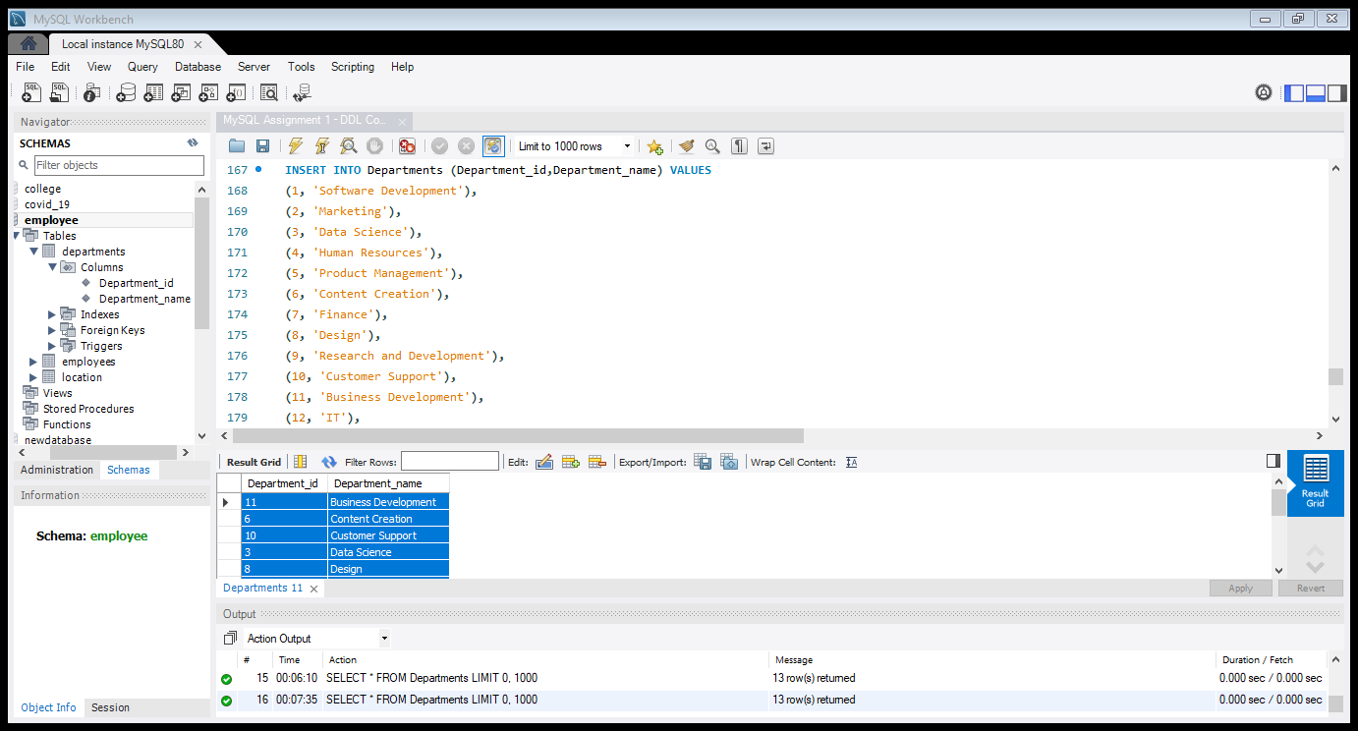
Pic: Departments table

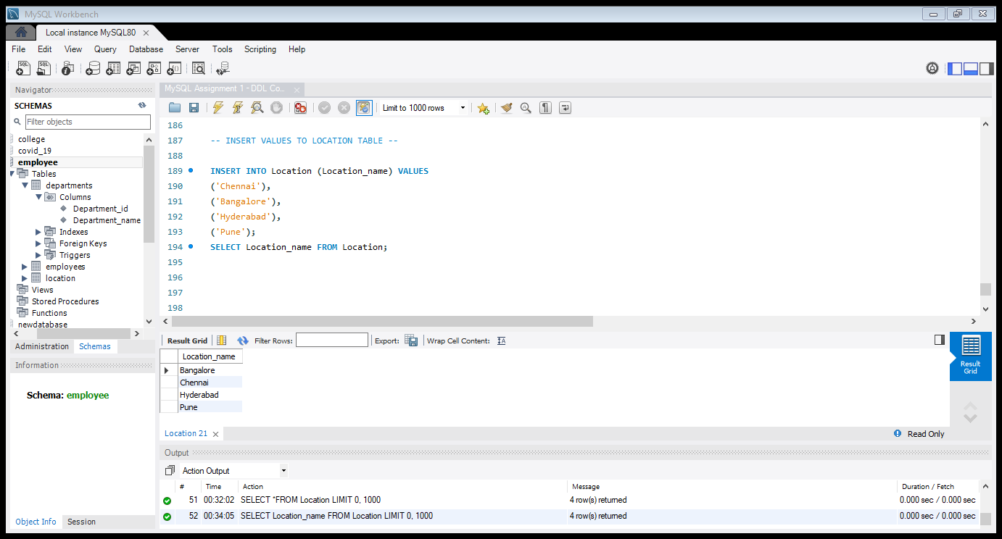
Pic: Location table
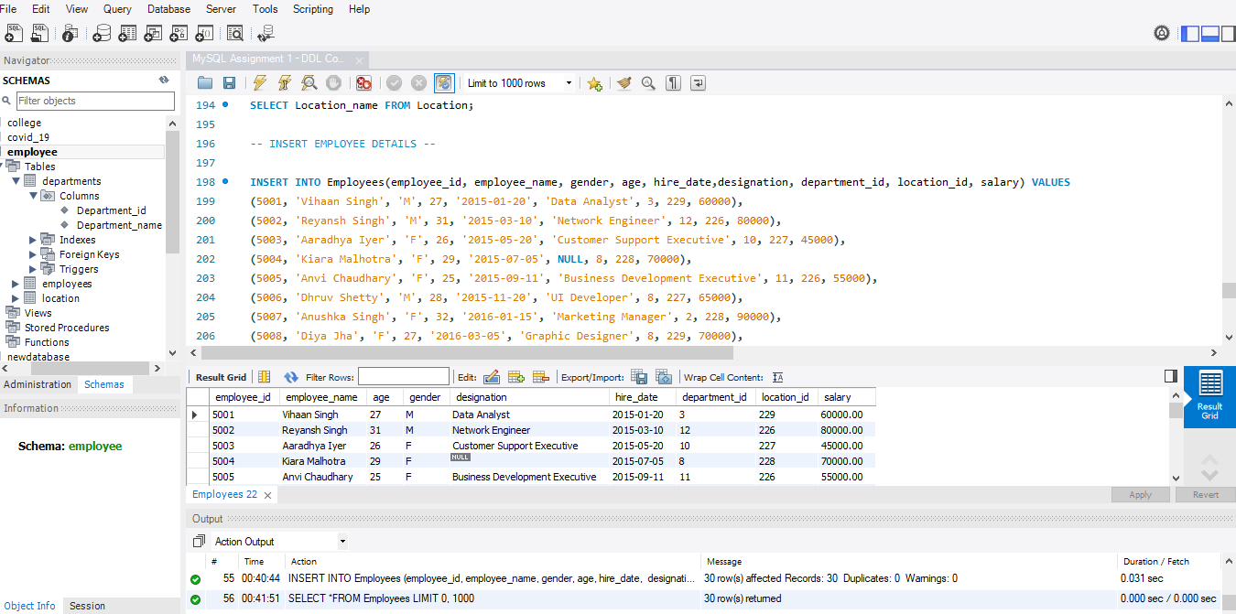
Pic: Employees table

1. Distinct Values
- A query to retrieve distinct salaries from the Employees table.
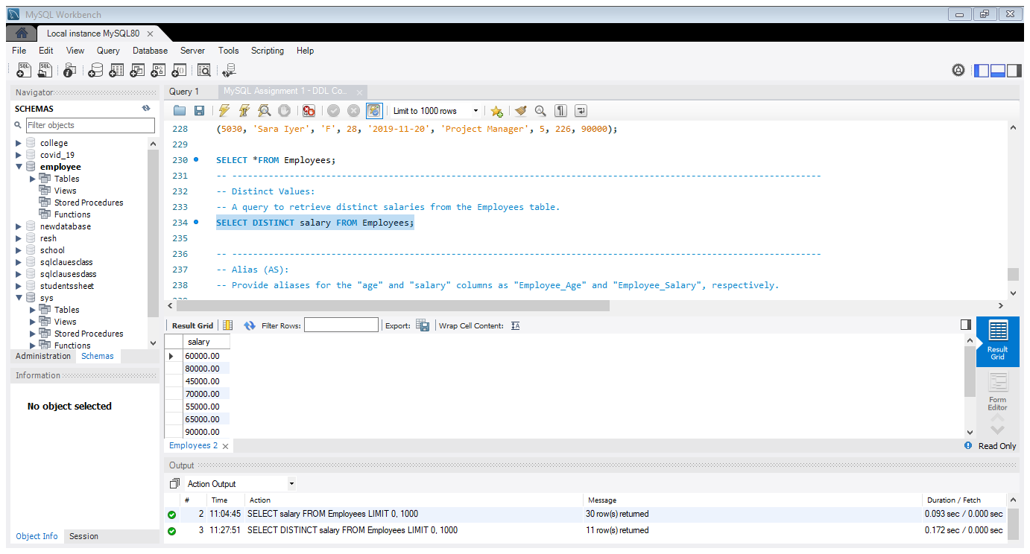

2. Alias (AS):
- Provide aliases for the "age" and "salary" columns as "Employee_Age" and "Employee_Salary", respectively.
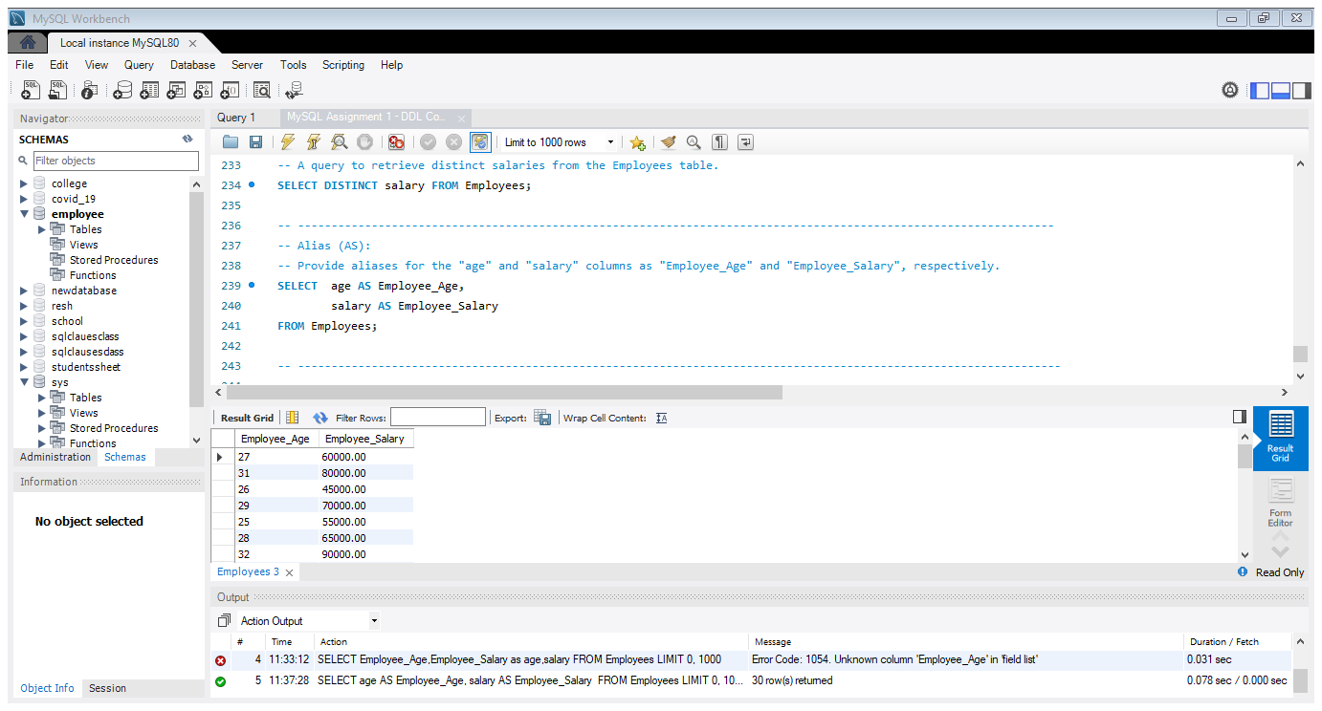

3. Where Clause & Operators
- Retrieve employees with a salary greater than ₹50000 and hired before 2016-01-01.
- Find the employee whose designation is missing and fill it with "Data Scientist".
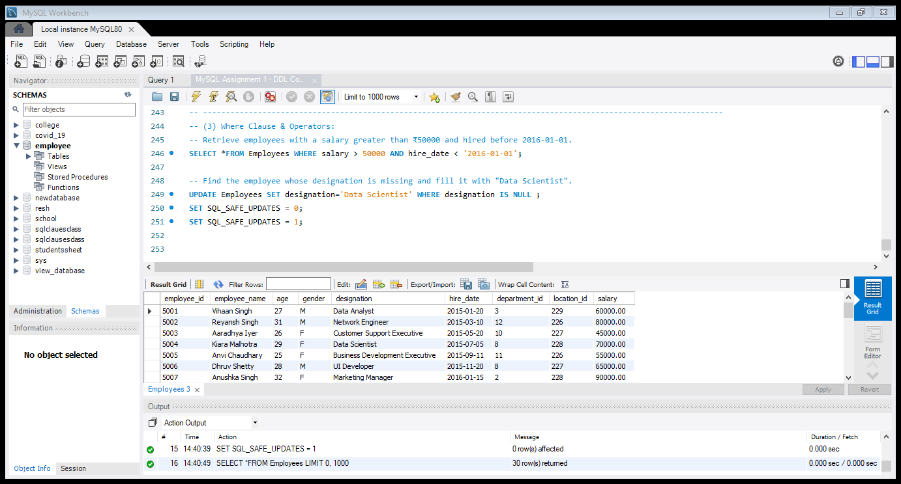
Sorting and Grouping Data:
- ORDER BY:
- Find employees sorted by department ID in ascending order and salary in descending order.
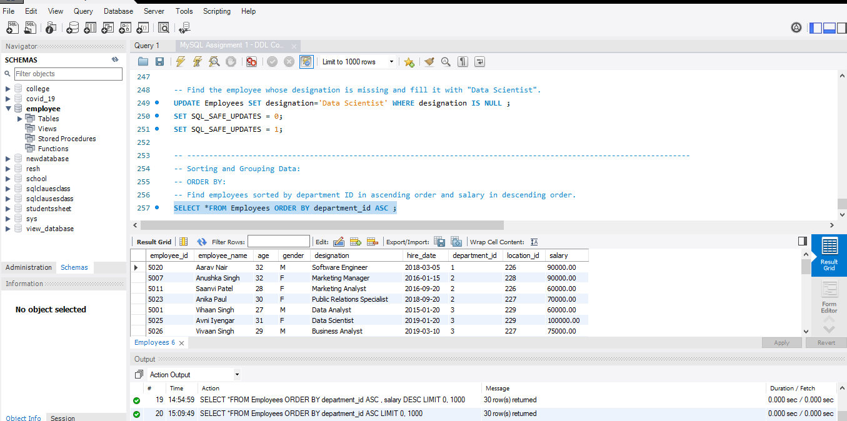
Pic : Employees sorted by department ID in ascending order

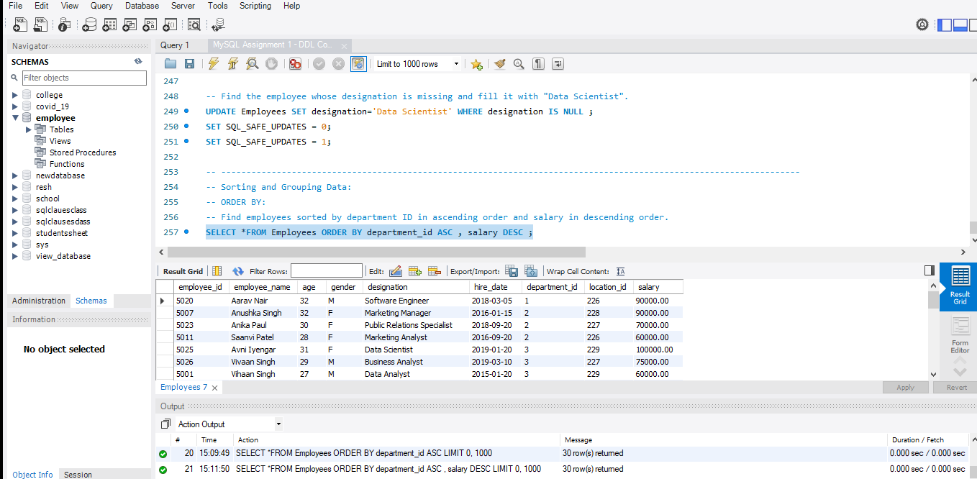
Pic : Employees sorted by department ID in ascending order & salary in descending order

salary DESC sorts employees by salary only within the same department ID

- LIMIT:
LIMIT in MySQL is used to restrict the number of rows returned by a query.
- Display the first 5 employees hired in the year 2018.
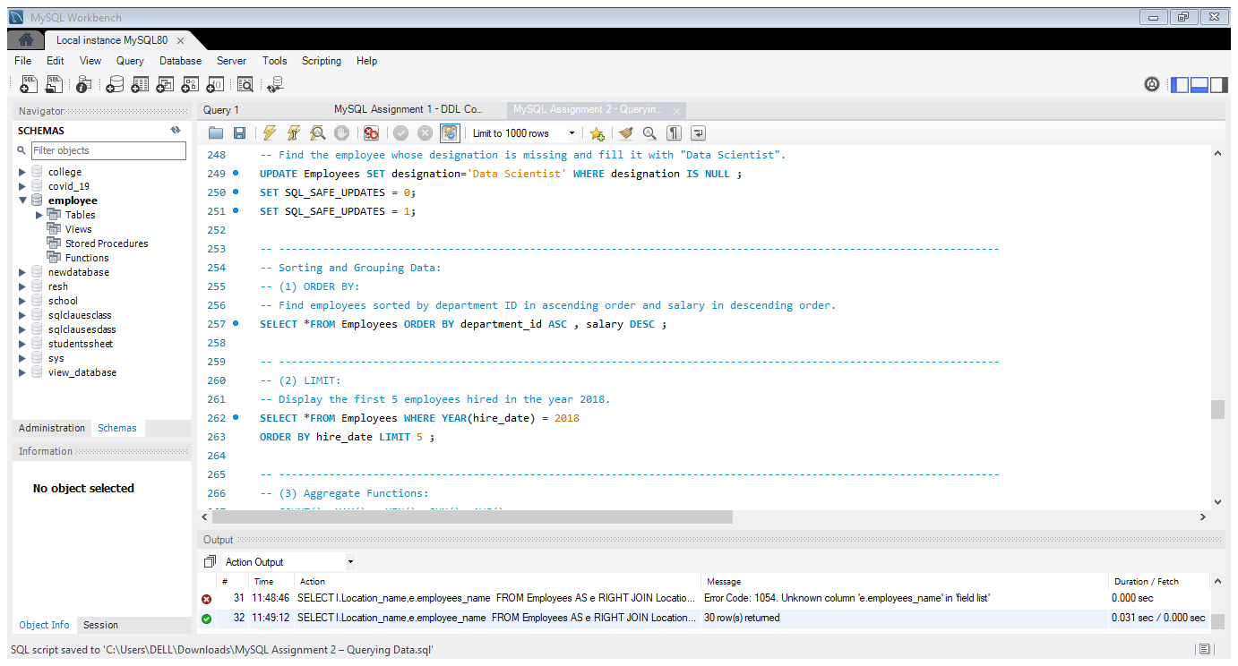

- Aggregate Functions:
- Aggregate functions in MySQL are used to perform calculations on multiple rows and return a single result.
- The main aggregate functions are COUNT(), SUM(), AVG(), MAX(), and MIN().
- They are commonly used with GROUP BY and HAVING clauses.

- Calculate the sum of all salaries in the Finance department.
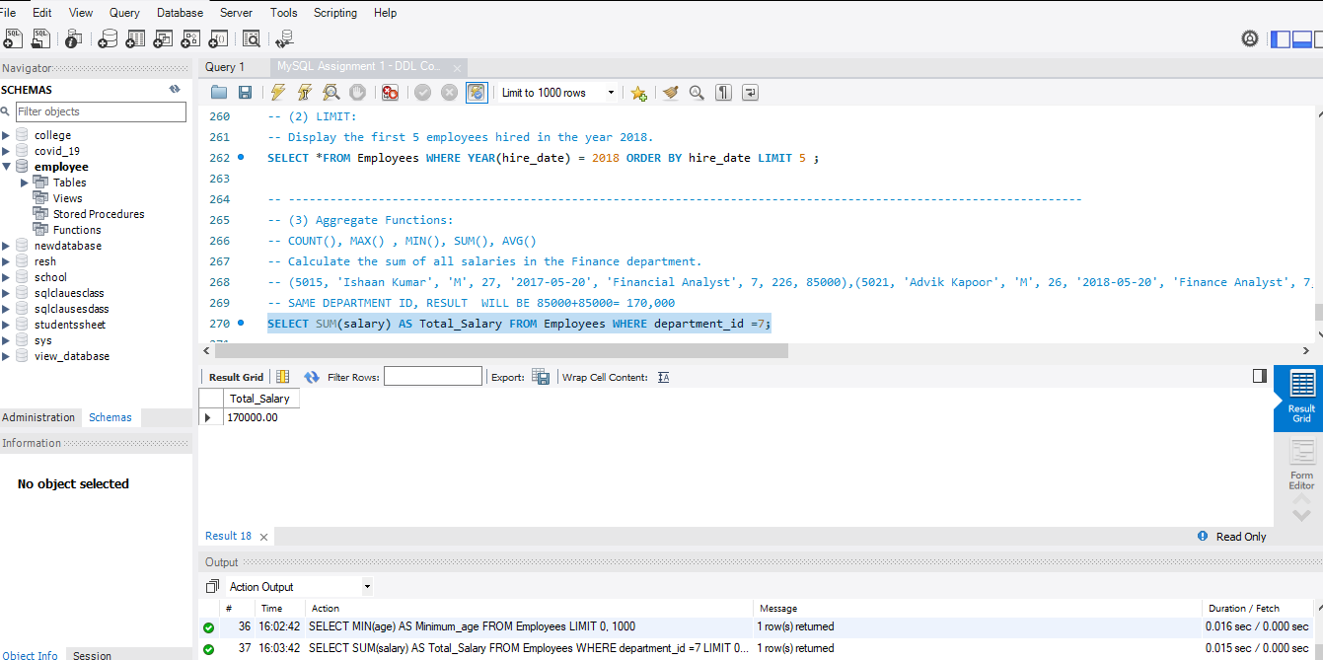

- Find the minimum age among all employees.
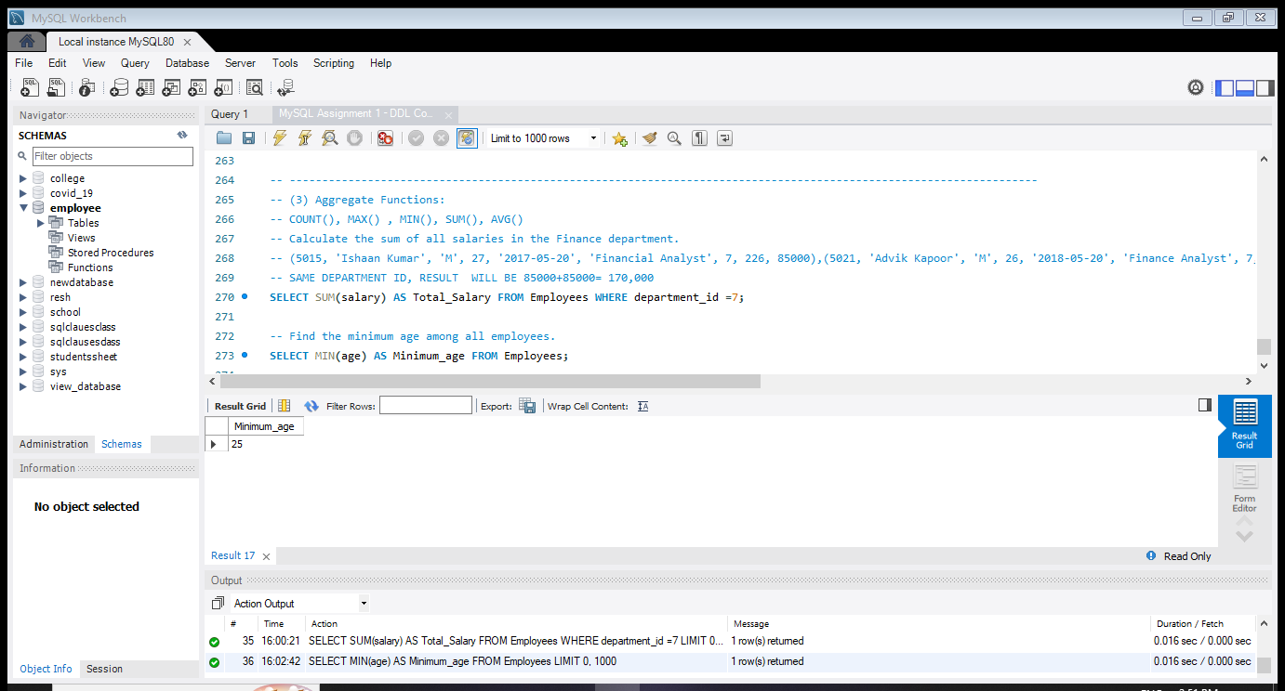
GROUP BY:
- List the maximum salary for each location.
- Calculate the average salary for each designation containing the word 'Analyst'.
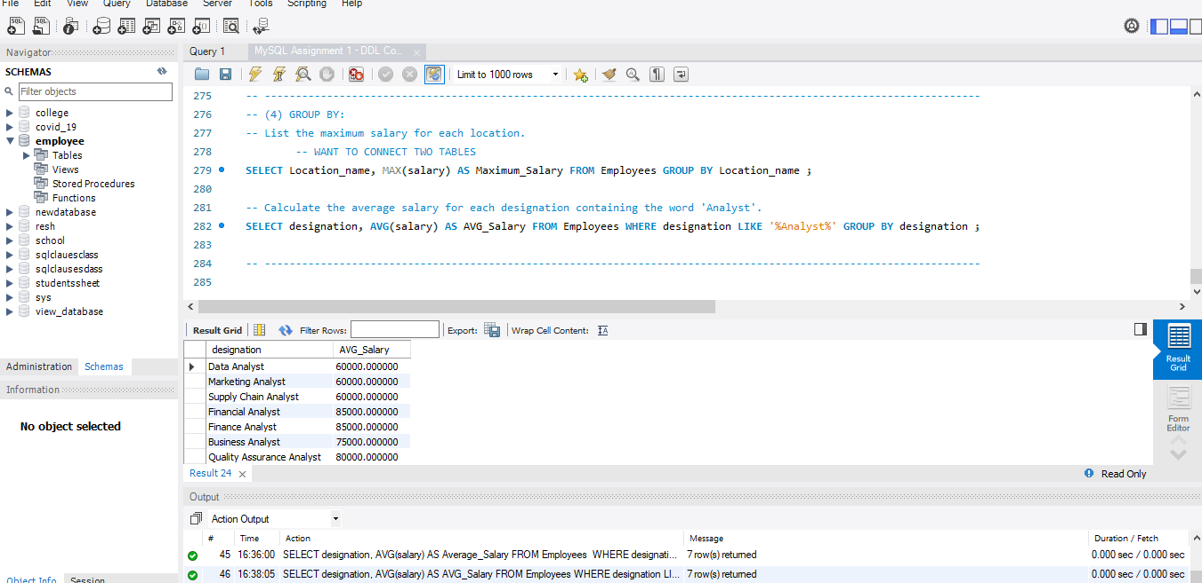

HAVING:
- Find departments with less than 3 employees.
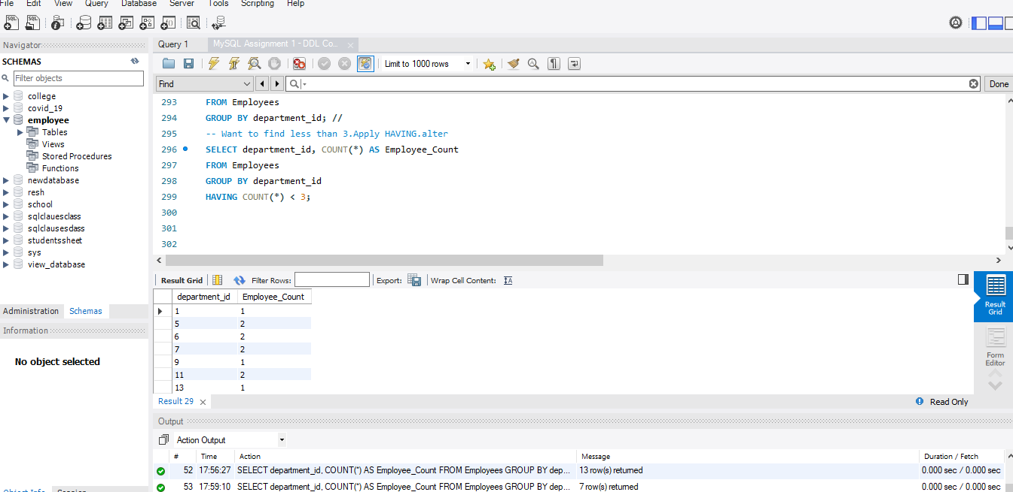
- Find locations with female employees whose average age is below 30.
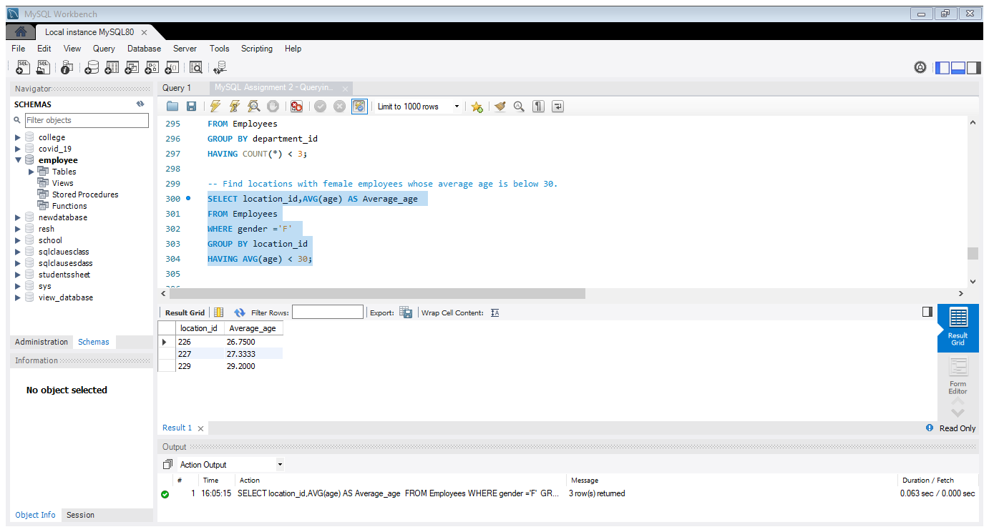

Joins:
Inner Join:
- List employee names, their designations, and department names where employees are assigned to a department.
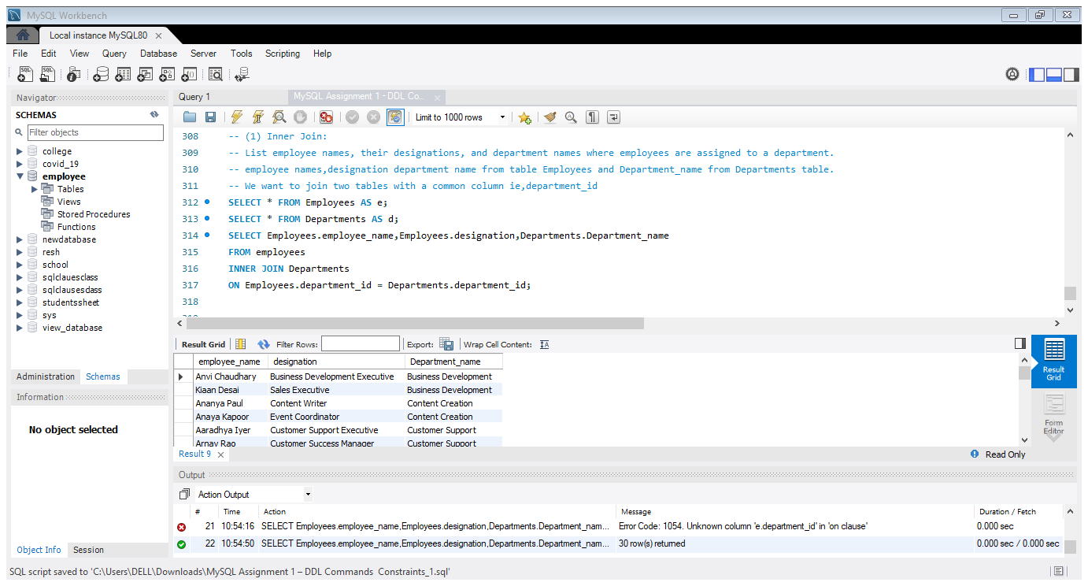
Left Join:
- List all departments along with the total number of employees in each department, including departments with no employees.
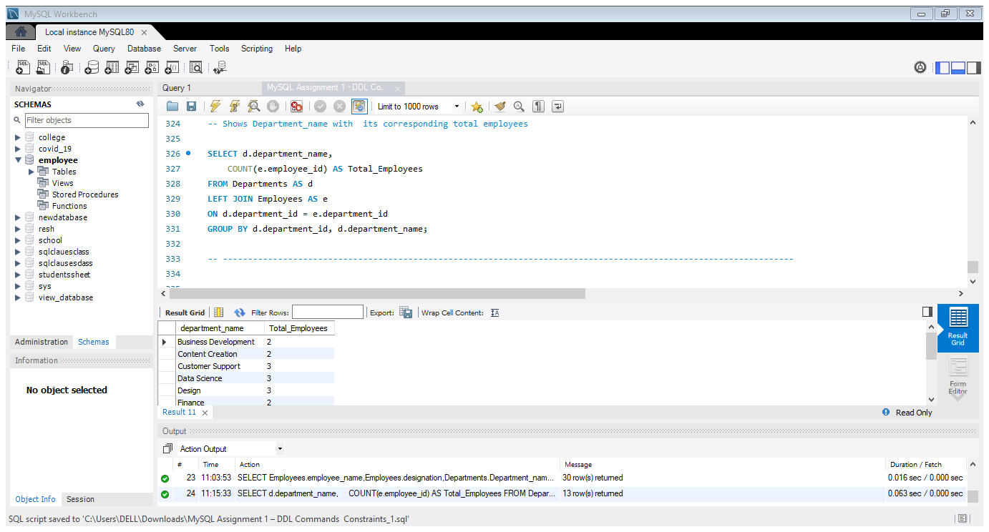

Right Join:
- Display all locations along with the names of employees assigned to each location. If no employees are assigned to a location, display NULL for employee name.


